- Your application should be able to add roles in the database dynamically in the db.

- Roles at application startup
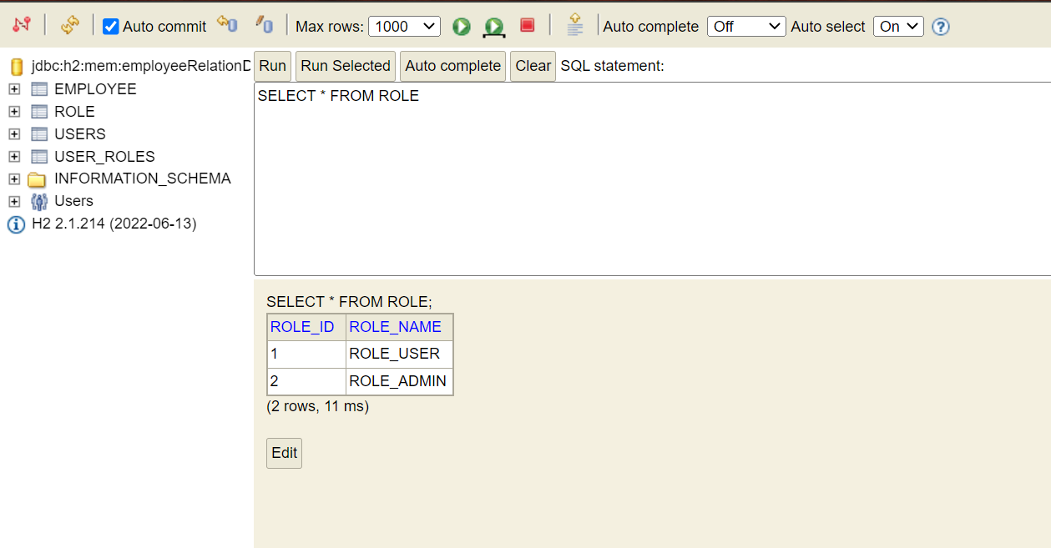

- Api response on postman
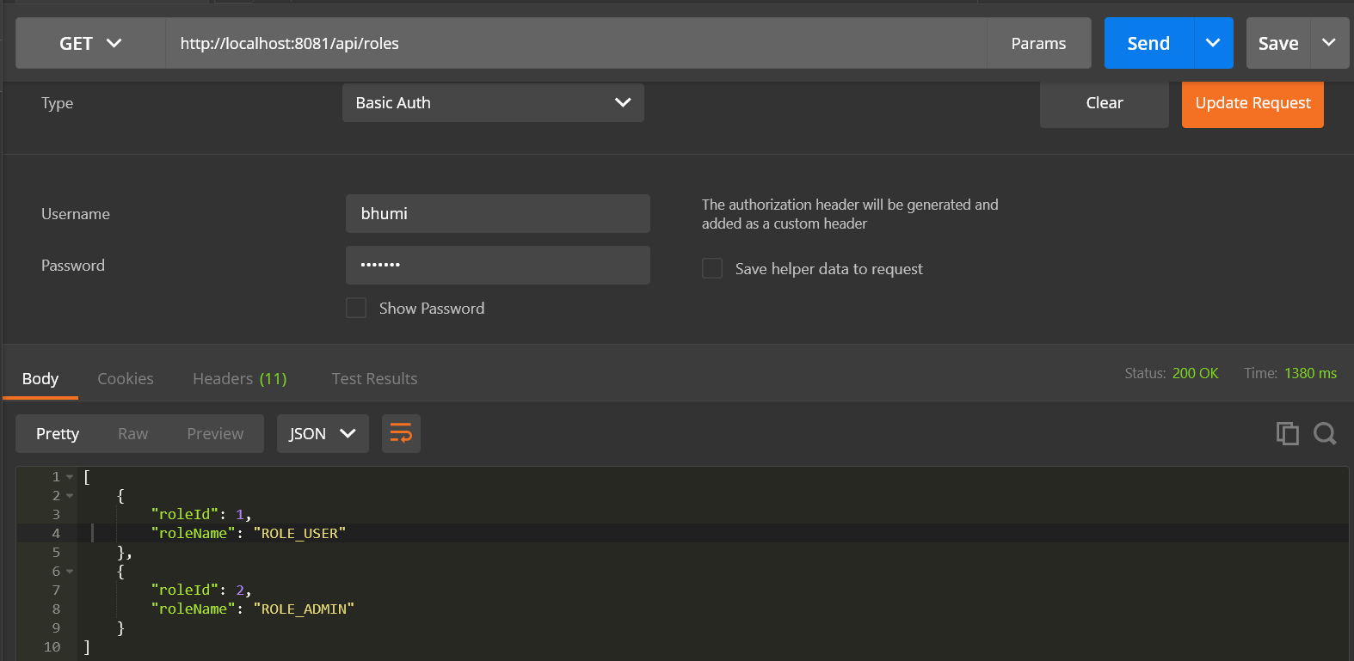

- Adding new role “DEVOPS” from postman

- New Role added in H2 DB
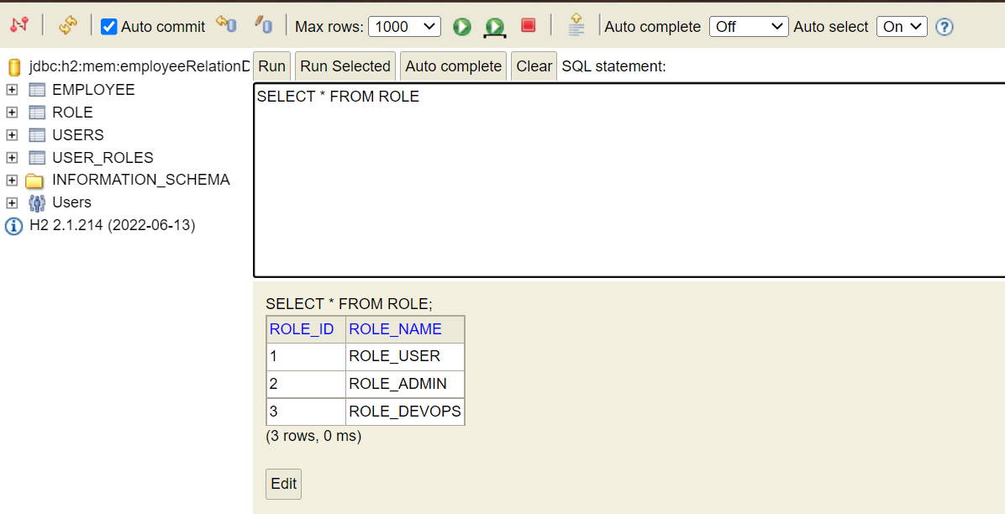

- Your application should be able to add Users in the db which can be used for authentication purposes.

- Users at application startup
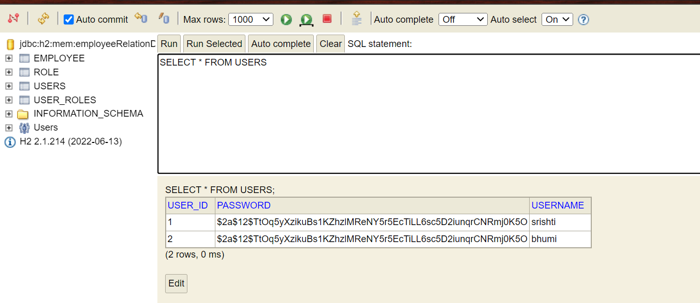

- Api response on postman
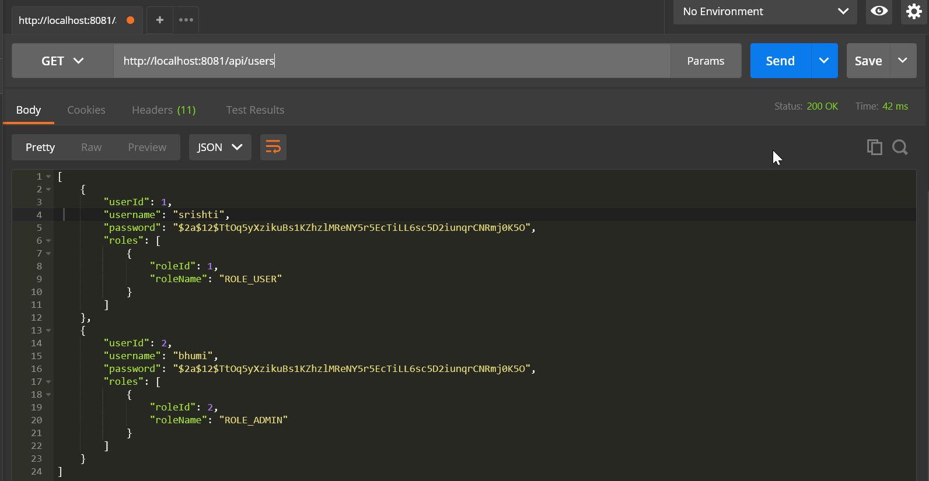

- Adding new user Rajesh for role “USER” and “DEVOPS” from postman
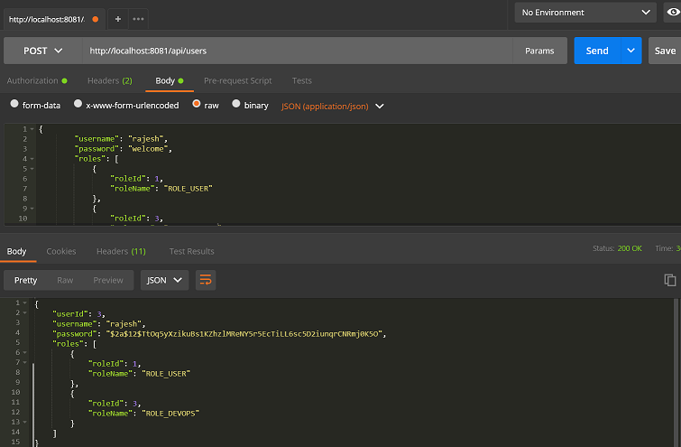
- Entries from H2 DB Tables
Users:
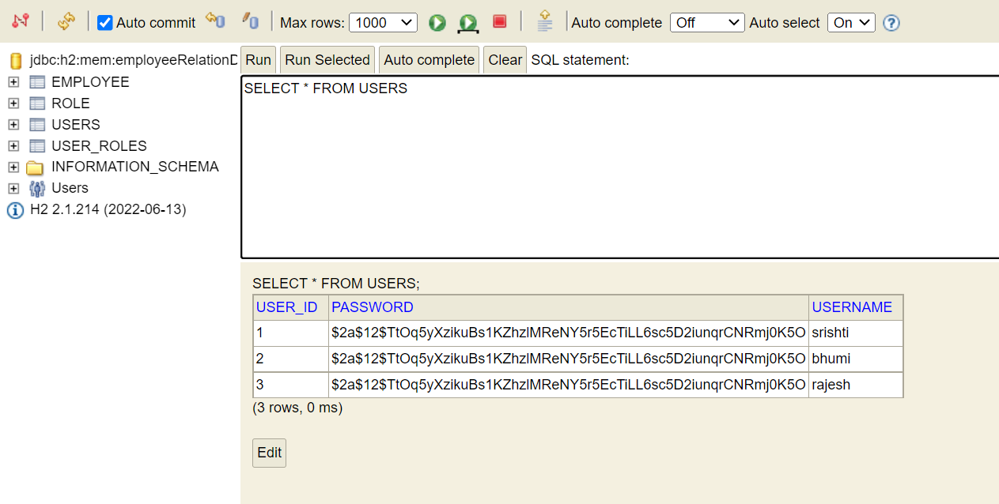

User_roles:
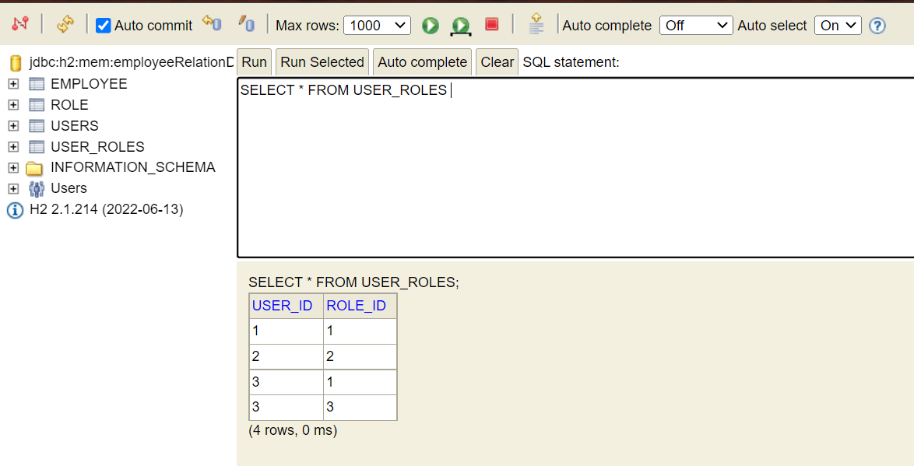

- Your application should be able to add employees data in the db if and only if the authenticated user is ADMIN-

- Add employee- “Kanchan Sharma” from postman using user- bhumi who has ADMIN role:
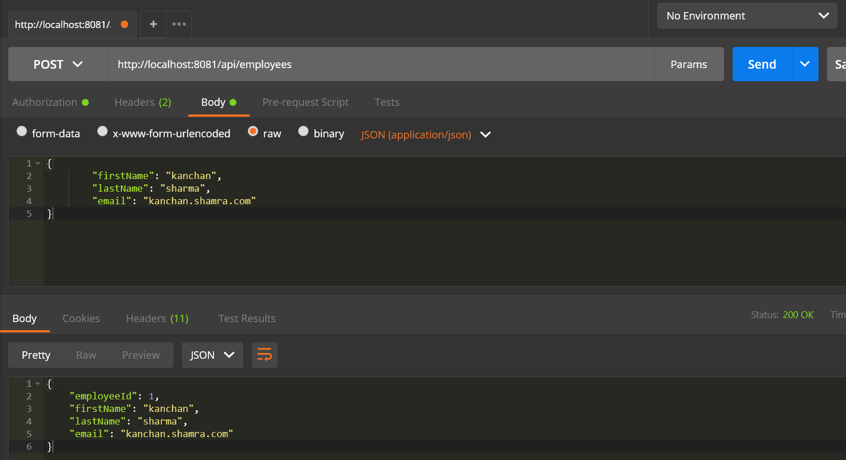

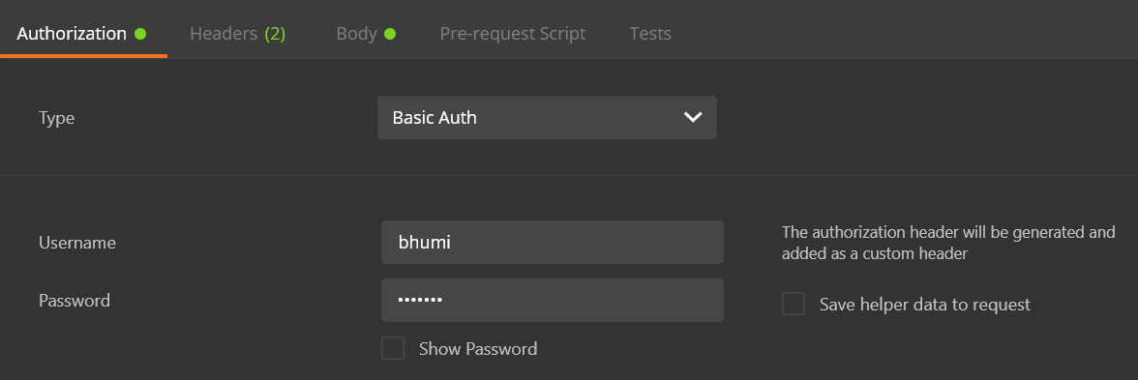

- Employee added in H2 DB:
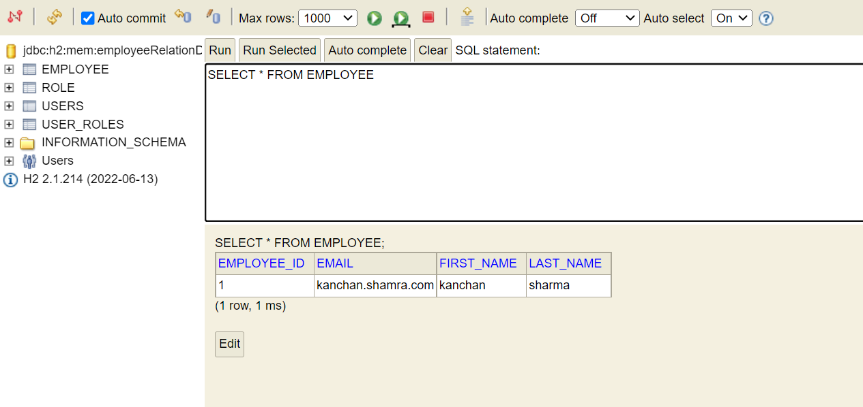

- Adding User – “Raghav Singh” using user- Srishti who has USER role:
Output- 403 response
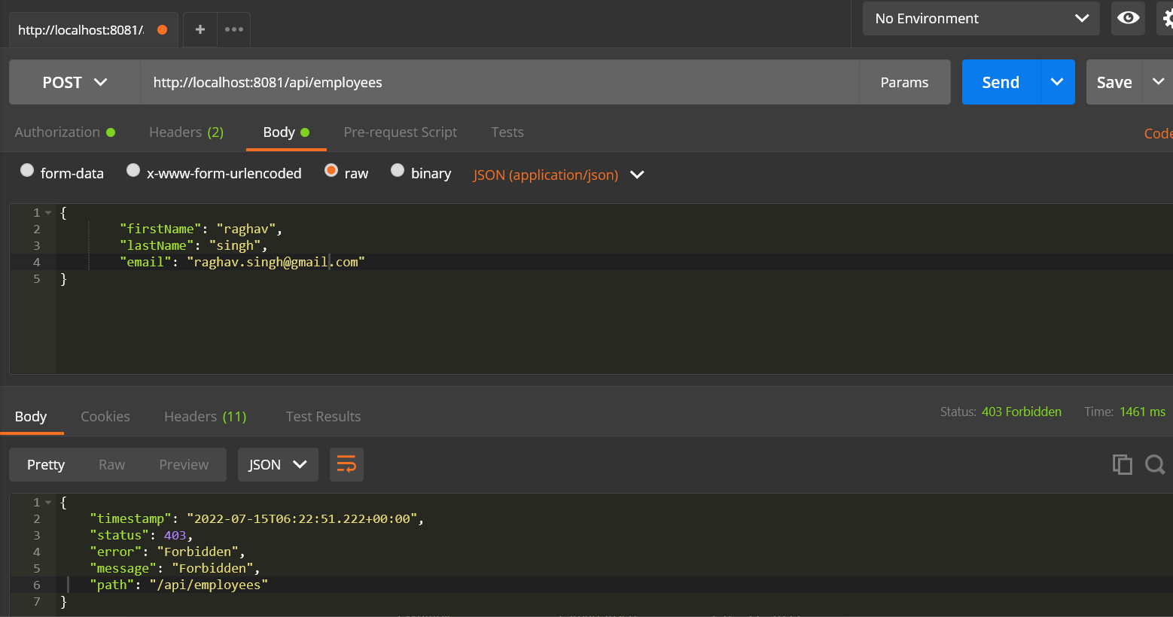
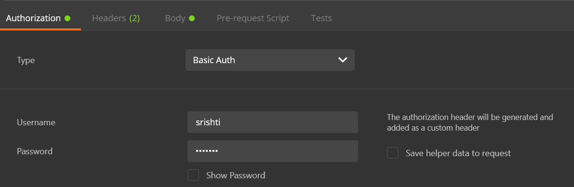

- Your application should provide endpoint to fetch Employee

- Employee in H2 DB
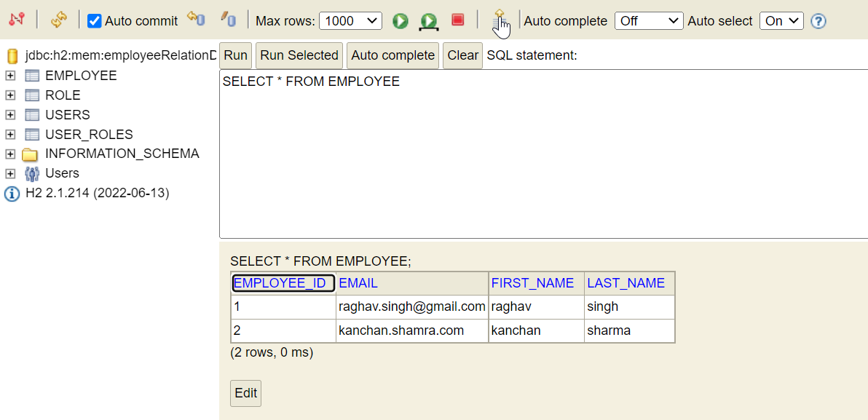
- Fetching all employees from api endpoint
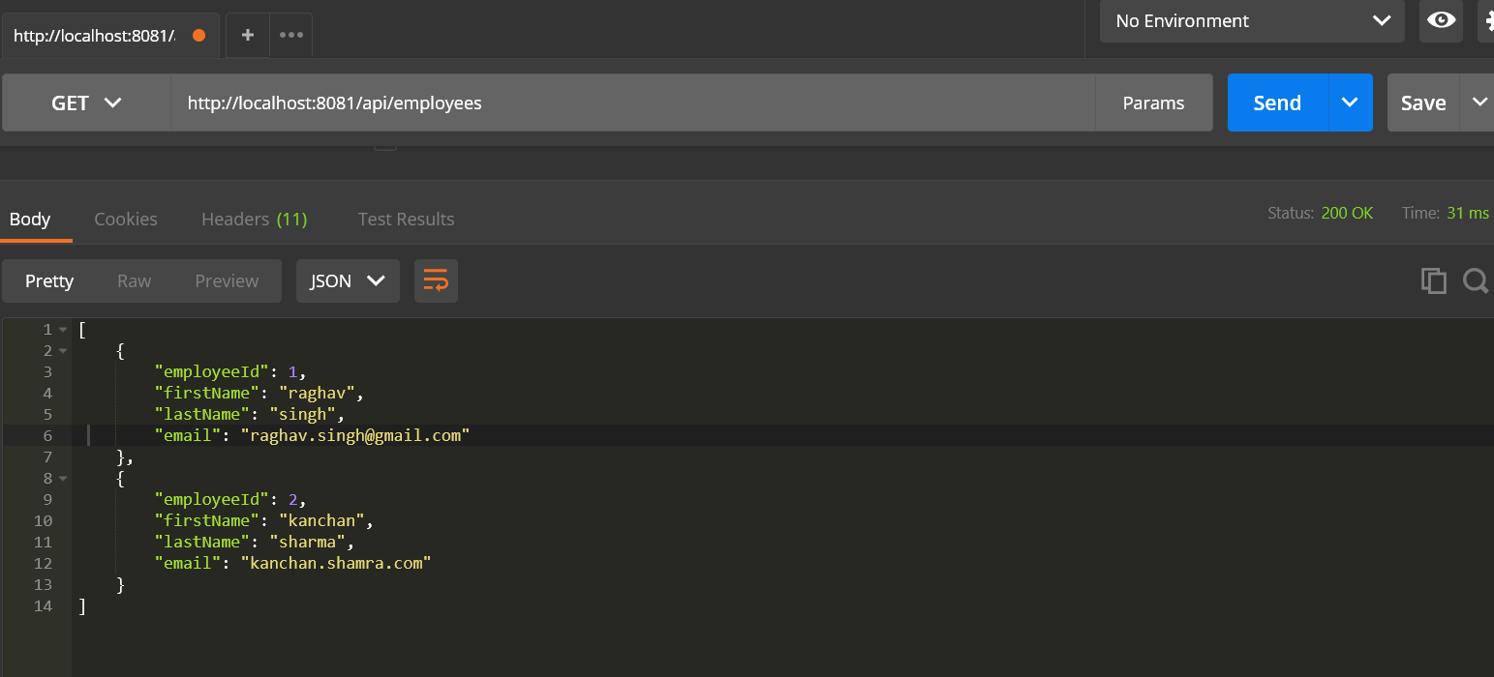

- Get an employee record specifically based on the id of that employee

- Fetching employeeid=2 record from api
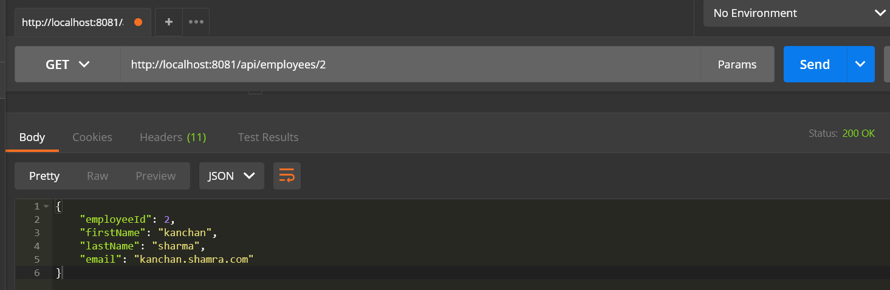

- Your application should provide an endpoint to update an existing employee record with the given updated json object.

- Updating email id for employeeid=1, record from h2 DB
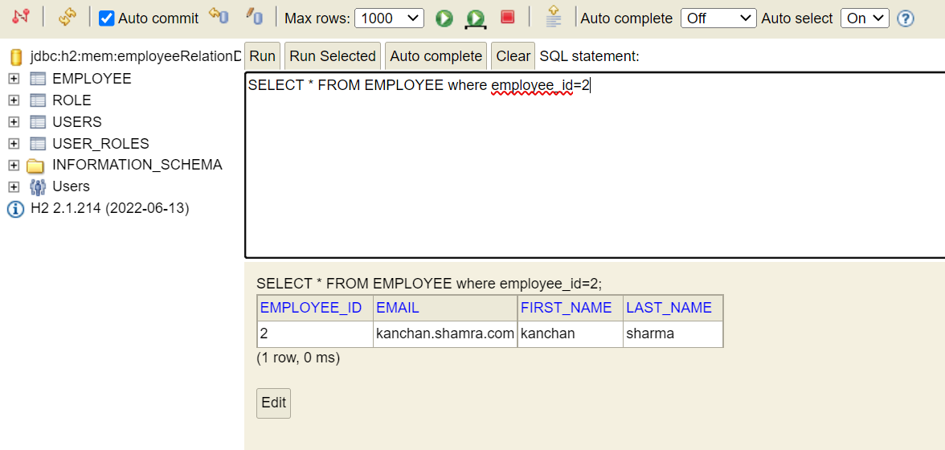

- Api to update the email id for employeeid=2

- Your application should provide an endpoint to fetch an employee by his/her first name and if found more than one record then list them all

- Search with firstname “Kanchan”

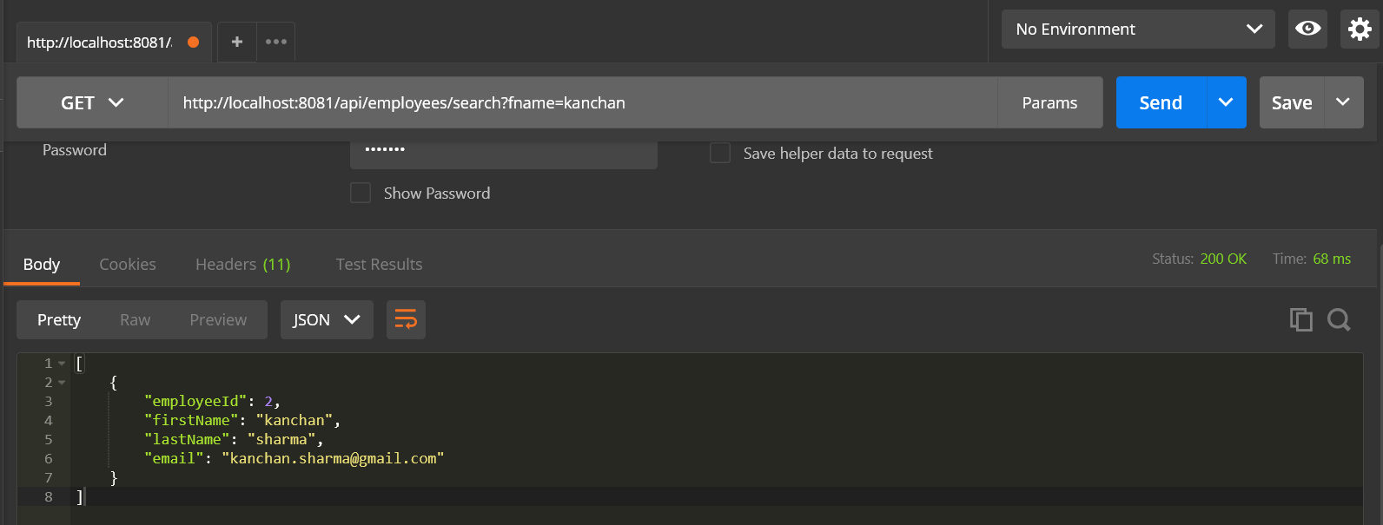

- Your application should be able to list all employee records sorted on their first name in either ascending order or descending order.

- Sort by firstname ASC order
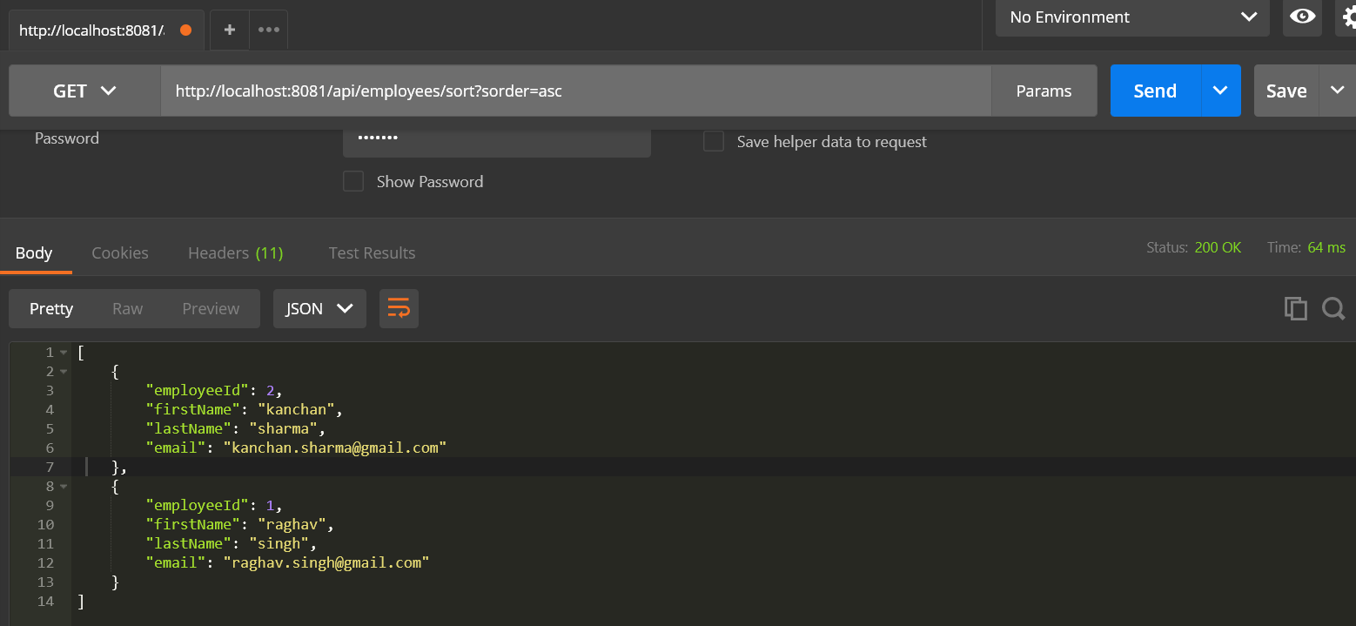
- Sort by firstname DESC order
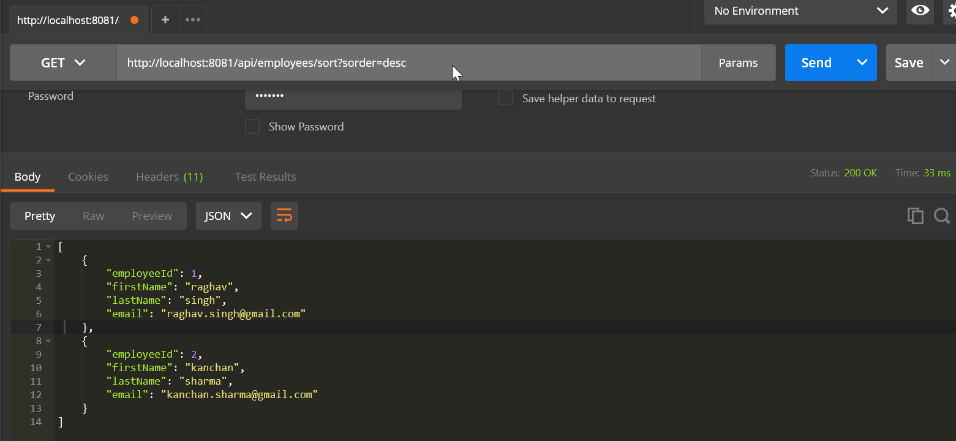

- Your application should also provide an endpoint to delete an existing employee record based on the id of the employee-
- Delete employee id=2 from api
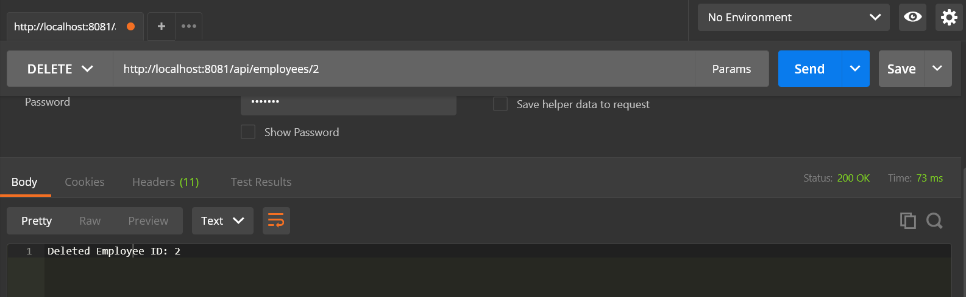

- Employee deleted from H2 db
